# 

CS-405 Deep Learning Fall 2023

Lab 08

Object Detection

|  |  |
| --- | --- |
| NAME | RAJA HAIDER ALI |
| CMS ID | 346900 |
| GROUP | 2 |

Date: 3rd Nov 2023

**Tasks:**

1. **Please fully train the YOLOv5s (small) and YOLOv8s (small) models on the provided dataset.**

**Answer:** performed.

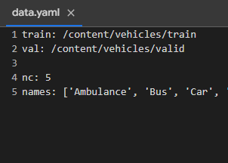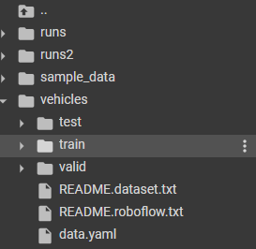

We have to update the paths of train and val in the data.yaml file otherwise the dataset won’t load. I copied and pasted their absolute paths from the directory structure

1. **Evaluate your models on the test sets and provide the mAP values.**

**Answer:**

**YOLOv5s:**

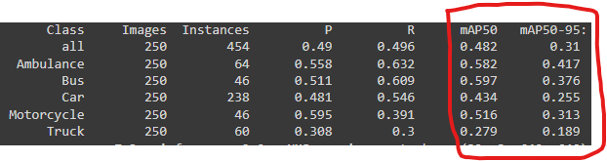

**YOLOv8s:**

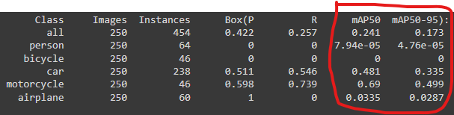

1. **Prepare a report in which you compare the performance of both the models. Please study the architectures of both YOLOV5 and YOLOV8 and illustrate these in your report.**

**Answer:** Both YOLOV5 AND YOLOV8 are based on You Only Look Once (YOLO) algorithm, which is known for its speed and accuracy. The table below represents their comparison.

|  |  |
| --- | --- |
| **YOLOV5** | **YOLOV8** |
| Older model | Newer and more advanced model |
| Has a coupled head module | Has a decoupled head module, which makes it faster and more accurate |
| It is anchor-based model | It is an anchor-free model |
| Less complex to train | More complex to train |
| Relatively slower, less accurate, and has a larger model size. | Fasters, more accurate, and has a smaller model size. |
| Better option when limited resources are available to train. | Better option when more training data and computational resources are available. |

1. **In your report, discuss which model is performing better on the test set and what can be the reason? If YOLOV8 is performing better, then what are the innovations that allow YOLOV8 to perform better than YOLOV5.**

**Answer:**

|  |  |
| --- | --- |
| **YOLOv5s** | **YOLOv8s** |
|  |  |

YOLOV5 is performing better than YOLOV8 because it has higher precision (P), recall [R], and mean Average Precision (mAP) values than YOLOV8.

The YOLOV8 is over-labeling the images. It is detecting objects whose ground truth values are not present in the label.txt file of the dataset, so when it compares the predicted labels with the ground truth values, the values don’t match and hence the accuracy and precision values fall. On the other hand, YOLOV5 is not over-labeling the images and hence its predicted labels match with ground truths and hence it is showing high accuracy and precision values.

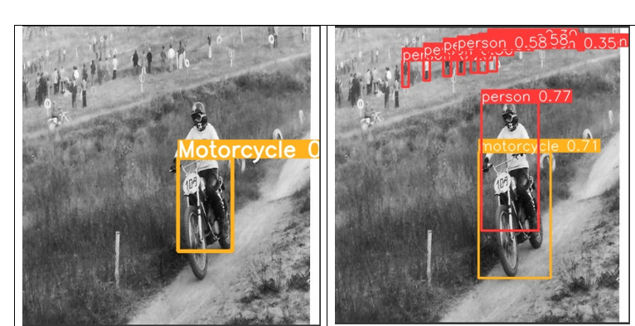

1. **Show predictions of both models on 4-5 test images in the report and compare them side by side.**

**Answer:**

|  |  |
| --- | --- |
| **YOLOv5s** | **YOLOv8s** |
|  |  |
| * misidentified ambulance as truck. * Didn’t identify car. | * misidentified ambulance as truck. * Identified car. * Probability values are high. |
|  |  |
| * Identified bus correctly with a lower probability. * Probability values are low. | * Identified bus correctly with a higher probability. * Probability values are high. |
|  |  |
| * Identified only the bus and the car. * Probability values are low. | * Identified bus, car, person and bicycle correctly. * Probability values are high. |
|  |  |
| * Identified motorcycle only. | * Identified person and motorcycle separately. * Probability values are high. |
|  |  |
| * Identified bus and car correctly. * Probability values are low. | * Identified bus, person, car, and traffic correctly. * Probability values are high. |